# Chapter 1 Making OB Work For Me.

## Section 1.1 The Value of OB to My Job and Career.

The term organizational behavior (OB) describes an interdisciplinary field dedicated to understanding and managing people at work. To achieve this goal, OB draws on research and practice from many disciplines, including: Anthropology, , Economics, , Ethics, , Management, , Organizational theory, , Political science, , Psychology, , Sociology, , Statistics, , Vocational counseling

A Contingency Perspective, The Contemporary Foundation of OB. A contingency approach calls for using the OB concepts and tools that best suit the situation, instead of trying to rely on “one best way.” This means there is no single best way to manage people, teams, or organizations. A particular management practice that worked today may not work tomorrow. What worked with one employee may not work with another. The best or most effective course of action instead depends on the situation.

Thus, to be effective you need to do what is appropriate given the situation, rather than adhering to hard-and-fast rules or defaulting to personal preferences or organizational norms. Organizational behavior specialists, and many effective managers, embrace the contingency approach because it helps them consider the many factors that influence the behavior and performance of individuals, groups, and organizations. Taking a broader, contingent perspective like this is a fundamental key to your success in the short and the long term.

How Self-Awareness Can Help You Build a Fulfilling Career. The Stanford Graduate School of Business asked the members of its Advisory Council which skills are most important for their MBA students to learn. The most frequent answer was self-awareness. The implication is that to have a successful career you need to know who you are, what you want, and how others perceive you. Larry Bossidy (former CEO of Honeywell) and Ram Charan (world-renowned management expert) said it best in their book Execution: “When you know yourself, you are comfortable with your strengths and not crippled by your shortcomings. … Self-awareness gives you the capacity to learn from your mistakes as well as your successes. It enables you to keep growing.” They also argue that you need to know yourself in order to be authentic, real and not fake, the same on the outside as the inside. Authenticity is essential to influencing others, which we discuss in detail in Chapter 12. People don’t trust fakes, and it is difficult to influence or manage others if they don’t trust you.

As professors, consultants, and authors, we couldn’t agree more! To help you increase your self-awareness we include multiple Self-Assessments in every chapter. These are an excellent way to learn about yourself and see how OB can be applied at school, at work, and in your personal life. Go to Connect, complete the assessments, and then answer the questions included in each of the Self-Assessment boxes.

Uncommon Sense. Let’s return to common sense. At first glance the contingency perspective may look like simple common sense. But it’s different. Common sense is often based on experience or logic, both of which have limits, and it suffers three major weaknesses you need to be aware of and avoid:

Overreliance on hindsight. Common sense works best in well-known or stable situations with predictable outcomes, what worked before should work again. But modern business situations are complex and uncertain and require adapting to change. Common sense is especially weak in responding to the unknown or unexpected. And because it focuses on the past, common sense lacks vision for the future.

Lack of rigor. People comfortable with common-sense responses may not apply the effort required to appropriately analyze and solve problems. If you lack rigor, then you are unlikely to define the problem accurately, identify the true causes, or recommend the right courses of action.

Lack of objectivity. Common sense can be overly subjective and lack a basis in science. In such cases we are not always able to explain or justify our reasoning to others, which is a sign that common sense lacks objectivity.

OB is a scientific means for overcoming the limits and weaknesses of common sense. The contingency approach in OB means you don’t settle for options based simply on experience or common practice if another solution may be more effective. Thus the goal of OB is to give you more than common sense and thus enhance your understanding of situations at work and guide your behaviors. This in turn will make you more attractive to potential employers and more effective once hired. Let’s explore this idea in more detail, beginning with the importance of possessing and developing both hard and soft skills.

Employers Want Both Hard and Soft Skills

Hard skills are the technical expertise and knowledge required to do a particular task or job function, such as financial analysis, accounting, or operations.

Soft skills relate to human interactions and include both interpersonal skills and personal attributes.

Table 1.1 shows four sought-after skills, along with a brief explanation of how we directly address them in this book.

1. Critical thinking
2. Problem solving
3. Judgment and decision making
4. Active listening

Some career experts, such as Chrissy Scivicque, the CEO of a career development and training firm and writer for Forbes and The Wall Street Journal, go so far as to say that most people have the technical skills to succeed at higher-level jobs. And even if some new technical knowledge is needed, it generally is easy to learn. However, as you rise through the hierarchy, your job generally will require a more developed set of soft skills. Skills like communication, emotional intelligence, ethics, and stress management. And mentions of critical thinking in job postings have doubled since 2009.

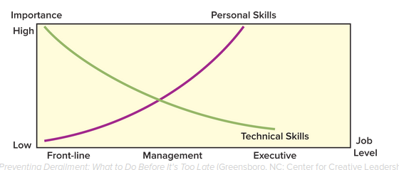

Performance Gives Me Credibility.

Performance matters because it gives you credibility with your peers and those you may manage. Just be aware that early in your career your bosses will be looking for more. They will evaluate your management potential, and their opinion will affect your opportunities. So even in a line (non-management) position, you need to know how to:

Apply different motivational tools (Chapter 5).

Provide constructive feedback (Chapter 6).

Develop and lead productive teams (Chapters 8 and 13).

Understand and manage organizational culture and change (Chapters 14 and 16).

## Section 1.2 Right vs. Wrong, Ethics and My Performance.

Ethics guides behavior by identifying right, wrong, and the many shades of gray in between. We will weave discussions of ethics throughout the book for three key reasons.

Employees are confronted with ethical challenges at all levels of organizations and throughout their careers.

Unethical behavior damages relationships, erodes trust, and thus makes it difficult to influence others and conduct business.

Unethical behavior also reduces cooperation, loyalty, and contribution, which hurts the performance of individuals, teams, and organizations.

Ethics also gets priority because many OB topics have a direct and substantial influence on the conduct of individuals and organizations. Notably, reward systems (Chapter 6), decision making (Chapter 11), leader behavior (Chapter 13), and organizational culture (Chapter 14) all can powerfully call upon our ethical standards at work. Let’s begin by describing cheating and other forms of unethical conduct at school and work.

Cheating.

The news now routinely reports about cheating in sports, such as alleged match-fixing by a number of professional tennis players and scores of instances of the use of performance-enhancing drugs: the Russian Olympic team’s systematic use and cover-up, cyclist Lance Armstrong’s public confession of drug use during each of his Tour de France victories (legal charges were ultimately filed), and Major League Baseball’s lifetime ban of pitcher Jenrry Mejia for three separate steroid violations. But cheating occurs in every other area of our lives too.

In early 2016, tennis star Maria Sharapova (left photo) tested positive for a performance-enhancing drug. She quickly admitted to the finding and apologized. Sepp Blatter (right photo), former president of soccer's international governing body FIFA, was at the heart of a scandal that rocked the organization, cost Blatter and others their jobs, and led to formal investigations across the globe. Investigators uncovered a well-entrenched and long-lasting pattern of bribes and other financial misconduct.

What about cheating at school? Anonymous surveys by the Josephson Institute of more than 23,000 students at private and public high schools across the United States found 59 percent admitted cheating on a test in the past academic year, and 32 percent reported plagiarizing material found on the Internet. Fifty-seven percent of participating high school students agreed with the statement “In the real world, successful people do what they have to do to win, even if others consider it cheating.”

The story doesn’t get any better in college. Turnitin.com, the plagiarism-checking service, reported finding 156 million matches between college student papers and previously published Internet material. The two top sources? Wikipedia and Yahoo Answers. As an example, 125 of 279 members of a particular government class at Harvard University were suspected of cheating on a take-home final. These are just a few examples and statistics of a very long list. What percentage of students at your school do you think cheat on homework assignments? Exams? Take-home finals?

Ethical Lapses, Legality, Frequency, Causes, and Solutions.

The vast majority of managers mean to run ethical organizations, yet corporate corruption is widespread. Some of the executives whose unethical behavior bankrupted the organizations they led, destroyed the lives of many employees, and caused enormous losses for employees, investors, and customers in the last few decades are Michael Milken (Drexel Burnham Lambert, 1990), Kenneth Lay and Jeff Skilling (Enron, 2001), Bernie Ebbers (WorldCom, 2002), Bernie Madoff (Madoff Investment Securities LLC, 2009), Hisao Tanaka (Toshiba, 2015), and Sepp Blatter (FIFA, 2015). None of these leaders acted alone.

Unethical Does Not Mean Illegal.

While extreme examples of unethical and illegal conduct make headlines, they are the exception. The truth is that very few unethical acts are also illegal, most are not punished in any way, and even if illegal, few are prosecuted.

This means you should not rely on the legal system to manage or assure ethical conduct at work. For instance, FoxConn, Apple Computer’s top supplier in China, was in the spotlight for its highly publicized ill-treatment of 1.2 million Chinese employees, who suffered 14-hour workdays, six- to seven-day workweeks, low wages, and retaliation for protesting.

American Airlines pilots provided another example in 2012 when they created widespread slowdowns in flights to pressure the company in negotiations with their union. American’s on-time performance dropped from 80 percent to 48 percent, versus 77 percent for Southwest and 69 percent for Delta. The slowdowns resulted in enormous costs and inconveniences for thousands of customers.

None of the conduct in these examples was illegal. The following OB in Action box provides another notable instance of how widespread unethical behavior has resulted in virtually no legal consequences.

Why Ethics Matters to Me and My Employer.

Criminal or not, unethical behavior negatively affects not only the offending employee but also his or her coworkers and employer. Unethical behavior by your coworkers, including company executives, can make you look bad and tarnish your career.

Thankfully, research provides us with clear ways to avoid such problems:

… sustainable businesses are led by CEOs who take a people-centered, inclusive approach rather than a controlling, target-driven one. They are people who listen, who foster cultures in which employees are not scared to point out problems and in which staff feel they have a personal responsibility to enact corporate values, be they health and safety concerns or putting the client’s interests first.

Ethical Dilemmas. Ethical dilemmas are situations with two choices, neither of which resolves the situation in an ethically acceptable manner. Such situations surround us at work and school. They highlight the fact that choosing among available options is not always a choice between right and wrong. Because such dilemmas are so frequent and potentially consequential, we include an Ethical/Legal Challenge feature at the end of each chapter that asks you to consider what you might do if confronted with difficult ethical choices at work.

What about Unethical Behavior in College and When Applying for Jobs?

A study of graduate students in the United States and Canada, including MBAs, found that peer behavior was by far the strongest predictor of student cheating, followed by severity of penalties and certainty of being reported. Students are more likely to cheat if their classmates cheat, and/or they think the probability of being caught is small, and if caught that the penalties will not be severe.

However, don’t be too quick to blame this bad behavior on your lying, cheating classmates. The same researchers acknowledge that there are many other potential reasons for cheating, such as perceived unfairness in grading. It also is possible that students see different degrees of cheating, for instance, in homework assignments versus on exams.

As for job hunting, an analysis of 2.6 million job applicant background checks by ADP Screening and Selection Services revealed that “ percent of applicants lied about their work histories, 41 percent lied about their education, and 23 percent falsified credentials or licenses.” Figure 1.2 highlights some of the most common and most outrageous lies told on résumés. Can you imagine being a recruiter? If you believe these numbers, half the people you interview could be lying to you about something! Many potential reasons for unethical behavior at work exist, beyond those listed in Table 1.2, such as:

Personal motivation to perform (“I must be No. 1”).

Pressure from a supervisor to reach unrealistic performance goals along with threats for underperforming.

Reward systems that honor unethical behavior.

Employees’ perception of little or no consequences for crossing the line.

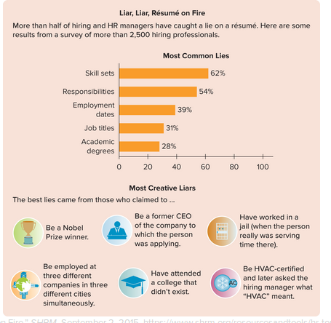

What Can I Do about It?

Like most others, you have or likely will witness questionable or even blatantly unethical conduct at work. You might be tempted to think, This is common practice, the incident is minor, it’s not my responsibility to confront such issues, and loyal workers don’t confront each other. While such rationalizations for not confronting unethical conduct are common, they have consequences for individuals, groups, and organizations. What can you do instead? Here are a few suggestions:

Recognize that it’s business and treat it that way. Ethical issues are business issues, just like costs, revenues, and employee development. Collect data and present a convincing case against the unethical conduct just as you would to develop a new product or strategy.

Accept that confronting ethical concerns is part of your job. Whether it is explicit in your job description or not, ethics is everybody’s job. If you think something is questionable, take action.

Challenge the rationale. Many lapses occur despite policies against them. If this is the case, ask, “If what you did is common practice or OK, then why do we have a policy forbidding it?” Alternatively, and no matter the rationale, you can ask, “Would you be willing to explain what you did and why in a meeting with our superiors or customers, or during an interview on the evening news?”

Use your lack of seniority or status as an asset. While many employees rely on their junior status to avoid confronting ethical issues, being junior can instead be an advantage. It enables you to raise issues by saying, “Because I’m new, I may have misunderstood something, but it seems to me that what you’ve done is out of bounds or could cause problems.”

Consider and explain long-term consequences. Many ethical issues are driven by temptations and benefits that play out in the short term. Frame and explain your views in terms of long-term consequences.

Suggest solutions, not just complaints. When confronting an issue, you will likely be perceived as more helpful and be taken more seriously if you provide an alternate course or solution. Doing so will also make it more difficult for the offender to disregard your complaint.

What Role Do Business Schools Play?

The researchers asked this question and found that the gender and academic background of deans, along with whether the school was public or private, predicted the likelihood that ethics courses were required. Female deans with a background in management were most likely to require ethics courses, while men with economics and finance backgrounds were least likely. Private and religiously affiliated schools were more likely than public schools to require classes in ethics. What is the case at your school? Does it align with these findings?

## Section 1.3 Applying OB to solving problems.

We all encounter problems in our lives. A problem is a difference or gap between an actual and a desired state or outcome. Problems arise when our goals (desired outcomes) are not being met (actual situation). So it is important to carefully consider what your goal or desired outcome is in order to define the problem appropriately. In turn, problem solving is a systematic process for closing these gaps.

A 3-Step Approach

Basics of the 3-Step Approach

Here are the three steps in our applied approach to problem solving.

Step 1: Define the problem. Most people identify problems reactively, after they happen, which causes them to make snap judgments or assumptions, often plagued by common sense, that incorrectly define the problem and its causes and solutions. All of us would likely benefit from Albert Einstein’s comment, “If I were given one hour to save the planet, I would spend 59 minutes defining the problem and one minute resolving it.” Let’s take Professor Einstein’s advice. The following tip will serve you well when defining problems throughout this course and your professional life.

Define problems in terms of desired outcomes. Then test each one by asking, “Why is this a problem?” Define problems in terms of desired outcomes or end states, compare what you want to what you have. Resist the urge to assume or infer you “know” what the problem and underlying causes are. Instead, start with available facts or details. Then ask yourself, “Why is this gap a problem?” For example, suppose you are disengaged from your work. How do you know this? What is the evidence? Perhaps you no longer go out of your way to help your coworkers and you stop responding to e-mails after work hours. You’ve defined your problem using evidence (or data). Now ask, “Why is this a problem?” Because when you are engaged, your coworkers benefit from you sharing your knowledge and experience. Coworkers and customers benefit from your responsiveness and willingness to respond to e-mails on their time line, even when it isn’t necessarily convenient for you (after hours).

Step 2: Identify potential causes using OB concepts and theories. Essential to effective problem solving, regardless of your approach, is identifying the appropriate causes. So far you have OB concepts like the contingency perspective and ethics, and many more are coming, to use as potential causes. The more options you have to choose from, the more likely you will identify the appropriate cause(s) and recommendation(s). To improve your ability to accurately identify potential causes, we provide the following tip for Step 2.

Test your causes by asking, “Why or how does this cause the problem?” Once you have confidently defined the problem in Step 1, disengagement, you need to identify potential causes (Step 2). Ask, “Why am I disengaged?” One common reason, backed by science, is that you perceive you were evaluated unfairly in your recent performance review. “Why or how did this cause disengagement?” Because if you feel unappreciated for what you’ve done, you are not motivated to go the extra mile to help your coworkers or customers. Asking “why” multiple times and following the line of reasoning will lead you to define and identify problems and causes more accurately.

Step 3: Make recommendations and (if appropriate) take action. In some workplace situations you will make recommendations, and in others you will also implement the recommendations. Here is a simple suggestion to improve the quality of your recommendations and overall problem solving.

How This Problem-Solving Approach Develops Throughout the Book.

Tools to Reinforce My Problem-Solving Skills.

## Section 1.4 Structure and Rigor in Solving Problems.

The Person–Situation Distinction.

Person factors are the infinite characteristics that give individuals their unique identities. These characteristics combine to influence every aspect of your life. In your job and career, they affect your goals and aspirations, the plans you make to achieve them, the way you execute such plans, and your ultimate level of achievement. Part One of this book is devoted to person factors.

Situation factors are all the elements outside ourselves that influence what we do, the way we do it, and the ultimate results of our actions. A potentially infinite number of situation factors can either help or hinder you when you are trying to accomplish something (see the following Problem-Solving Application box). This is why situation factors are critically important to OB and your performance.

Which Influences Behavior and Performance More, Person or Situation Factors?

People and Situations Are Dynamic

People change, situations change, and the two change each other. To illustrate:

People bring their abilities, goals, and experiences to each and every situation, which often changes the situation.

Conversely, because situations have unique characteristics, such as opportunities and rewards, they change people. What you value in a job will likely differ between now and the time you are trying to make a move to senior management.

It also is true that the current job market and employer expectations differ from those at the height of the technology bubble in the late 1990s or in the depths of the Great Recession in 2007–2009. In the first scenario employees changed, and in the second the situation or environment changed.

Finally, your manager, a situation factor, can change what you do, the way you do it, and your effectiveness. You can exert the same influence on your manager.

The bottom-line implication for OB and your work life is that knowledge of one type of factor without the other is insufficient. You need to understand the interplay between both person and situation factors to be an effective employee and manager.

How Does the Person–Situation Distinction Help Me Apply OB Knowledge?

Many companies restructure indiscriminately and cut large percentages from their employee ranks. Assume you and five coworkers, who all do the same job, are downsized. You all experience the same event, but your reactions will vary. For instance, you might not feel too bad if you didn’t like the job and were considering going to graduate school anyway. Two of your coworkers, however, may be devastated and depressed.

Nevertheless, because the downsizing event was the same for all of you (the situation factors were identical), we can assume that the differences in everyone’s reactions were due to things about you as individuals (person factors), such as other job opportunities, how much each of you likes the job you just lost, your ratio of savings to debt, and whether you have kids, mortgages, or a working spouse. The person–situation distinction, therefore, provides a means for classifying OB concepts and theories into causes of behavior and problems.

Levels, Individual, Group/Team, and Organization

We saw above that OB distinguishes among three levels at work: individual, group/team, and organizational. To illustrate how considering levels helps in solving real-world problems, think about the many reasons people quit their jobs.

Some people quit because their job doesn’t fulfill what they value, such as challenging and stimulating work (an individual-level input).

Others quit because of conflicts with their boss or because they have nothing in common with their coworkers (a group/team-level process).

A common reason people quit is a faulty reward system that unfairly distributes raises, bonuses, and recognition (an organizational-level process).

Applying OB Concepts to Identify the Right Problem

Nothing causes more harm than solving the wrong problem. To illustrate, assume that many people in your department at work are quitting. What could be the reason? The person–situation distinction allows you to consider unique individual factors as well as situation factors that might be the source of the problem. And considering the levels of individual, group, and organization will allow you to look at each for possible causes.

For example:

Person factors. Do your departing coworkers have something in common? Is there anything about their personalities that makes work difficult for them, such as a preference to work collaboratively rather than independently? What about their ages? Gender? Skills?

Situation factors. Have there been changes in the job market, such as a sudden increase in employment opportunities at better wages? Have working conditions such as promotion opportunities become less attractive in your organization?

Individual level. Has the job itself become boring and less meaningful or rewarding to the employees who quit?

Group/team level. Have there been any changes to the work group, including the manager, that might make work less satisfying? How does turnover in your department compare to that in other departments in the organization? Why?

Organizational level. Has the organization changed ownership, or rewritten company policies, or restructured such that the most desirable positions are now at the headquarters in another state?

By following this approach and asking these questions, you widen your focus and review a larger number of possible causes, increasing the likelihood you will identify the right problem. If you don’t quite follow this example, then have no fear. We analyze a turnover scenario in the last section of this chapter and provide a more detailed application. Stay tuned!

## Section 1.5 The Organizing Framework for Understanding and Applying OB.

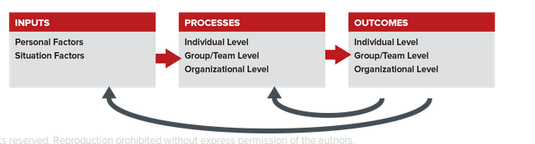

A Basic Version of the Organizing Framework

The foundation of the Organizing Framework is a systems model wherein inputs influence outcomes through processes. The person and situation factors are inputs. We’ve organized processes and outcomes into the three levels of OB, individual, group/team, and organizational.

This framework implies that person and situation factors are the initial drivers of all outcomes that managers want to achieve. This is the case because inputs affect processes, and processes affect outcomes. And because events are dynamic and ongoing, many outcomes will in turn affect inputs and processes. See Figure 1.3. The relationships between outcomes at one point in time and inputs and processes at another are shown as feedback loops in the Organizing Framework (the black arrows at the bottom of the figure).

Using the Organizing Framework for Problem Solving

You can use the Organizing Framework at all three steps of the problem-solving process to add rigor, intelligently apply your OB knowledge, and in turn improve your performance.

Step 1: Define the problem. Problems can be defined in terms of outcomes in the Organizing Framework, and these outcomes occur at three levels.

Step 2: Identify causes. Causes are often best thought of in terms of inputs (person or situation) or processes at various levels (individual, group/team, organizational).

Step 3: Make recommendations. Consider the most appropriate solutions using your OB knowledge and tools. Then map these onto the causes (inputs or processes).

Selecting a Solution and Taking Action (if appropriate),

Don’t Forget to Consider Constraints

As a matter of practicality, most people lack the time, knowledge, or access to data to routinely follow such a rigorous procedure. Therefore, your selection most often requires you to consider various constraints, on time, money, your own authority, and information, that can occur at different levels. We close this chapter with practical pointers on how to select the best solution.

Applied Approaches to Selecting a Solution

You can save time and hassle with the following practical advice from renowned problem-solving expert and professor Russell Ackoff. Ackoff recommends first deciding how complete a response you are looking for. Do you want the problem to be resolved, solved, or dissolved?

Resolving problems is arguably the most common action managers take and simply means choosing a satisfactory solution, one that works but is less than ideal. Putting on a “doughnut” or temporary spare tire fixes a flat, but it certainly is not ideal and is unlikely to last.

Solving problems is the optimal or ideal response. For instance, you could buy a new, high-quality, full-size spare to keep in your trunk (not the typical doughnut or the “run-flats” that manufacturers frequently provide).

Dissolving problems requires changing or eliminating the situation in which the problem occurs. Keeping with our example, the city you live in could build and utilize effective public transportation and thus remove the necessity of having cars (and tires) altogether.

Basic Elements for Selecting an Effective Solution

After deciding whether to resolve, solve, or dissolve your identified problem, you need to select the most effective solution. A problem-solving expert says: “The essence of successful problem solving is to be willing to consider real alternatives.” To help you choose among alternatives identified in Step 2, we distilled three common elements that will help you qualify the best solution:

1. Selection criteria. Identify the criteria for the decision you must make, such as its effect on:
   1. Bottom-line profits.
   2. You and classmates or coworkers.
   3. Your organization’s reputation with customers or the community.
   4. Your own values.
   5. The ethical implications.
2. Consequences. Consider the consequences of each alternative, especially trade-offs between the pros and the cons, such as:
   1. Who wins and who loses.
   2. Ideal vs. practical options.
   3. Perfection vs. excellence.
   4. Superior vs. satisfactory results.
3. Choice process. Decide who will participate in choosing the solution. (If more than one person, agree on the method. Will you vote? Will the vote be public or secret? Unanimous or simple majority?):
   1. You
   2. Third party
   3. Team

In every case, consider the necessary resources, including which people will be key sources of support for (and resistance to) your ultimate selection. Consider who can help and who can hurt your efforts, what’s in it for them?

## Section 1.6 Preview and application of What i will Learn.

The 3-Step Problem-Solving Approach.

The Organizing Framework.

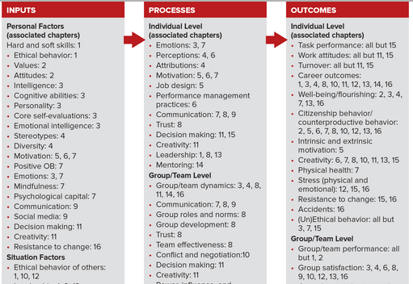

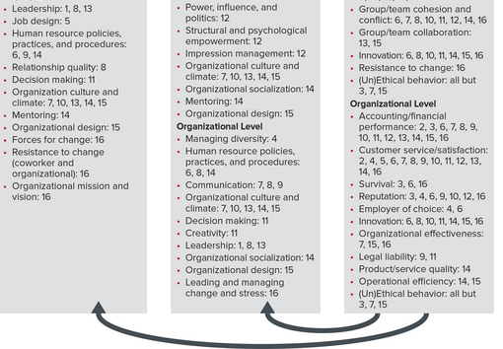

Using the Framework for Learning.

Breadth and Power of OB.

Hypothetical Problem-Solving Scenario.

Step 1: Define the Problem.

Step 2: Use OB to Highlight the Causes.

Step 3: Generate Effective Recommendations Using OB.

Using the Framework for Learning

# Chapter 1 End.